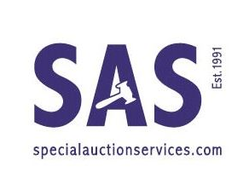

SPECIAL AUCTION SERVICES
AUCTION DATES 2023

Auctions start at 10:00 am
(Please check with us prior to auction)

Antiques & Collectables 03rd May 2023
TWO DAY: Military & Collectables Auction 10th & 11th May 2023
Jewellery, Watches, & Silver Auction 18th May 2023
A Single Owner Vintage Film Poster & Memorabilia 23rd May 2023
Music & Entertainment Auction 31st May 2023

Antiques & Collectables Auction 06th June 2023
Photographica & Cameras Auction 13th June 2023
Dolls & Teddy Bears Auction 20th – 22nd June 2023
Glorious Trains Auction (Part Two) 27th June 2023

Coins & Medallions Auction 04th July 2023
TWO DAY: Antiques, Fine Art, Jewellery & Silver Auction 13th July 2023
Toys for the Collector Auction 18th July 2023
Music & Entertainment Auction 25th July 2023

Antiques & Collectables Auction 01st August 2023
TWO DAY: Military & Collectables Auction 08th – 09th August 2023
Photographica & Cameras Auction 15th August 2023
Popular Diecast Toys & Trains Auction 22nd August 2023

Online catalogue will be published 2-3 weeks before the sale date.
Please book an appointment to view the sale.

Please note some of the sale dates are subject to alteration, so please check with us.
Entries for all our auctions are accepted up to 6 weeks prior to sale dates.
Please contact the SAS team for further details on 01635 580595

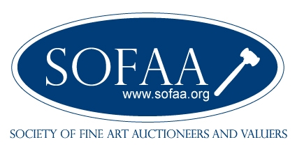
Special Auction Services
Plenty Close, off Hambridge Road
NEWBURY. RG14 5RL
01635 580595

